JEwer ELite Goaltending
  - Program Information and Policies
Last Modified March 12th, 2018

On-ICE PROGRAMS & SESSIONS
At JEG, we strive to use a balance of effective and innovative techniques combined with a positive enthusiastic atmosphere, to create the most beneficial experience for your goalie. We have several different program and session formats and options for goalies of all ages and skill levels.

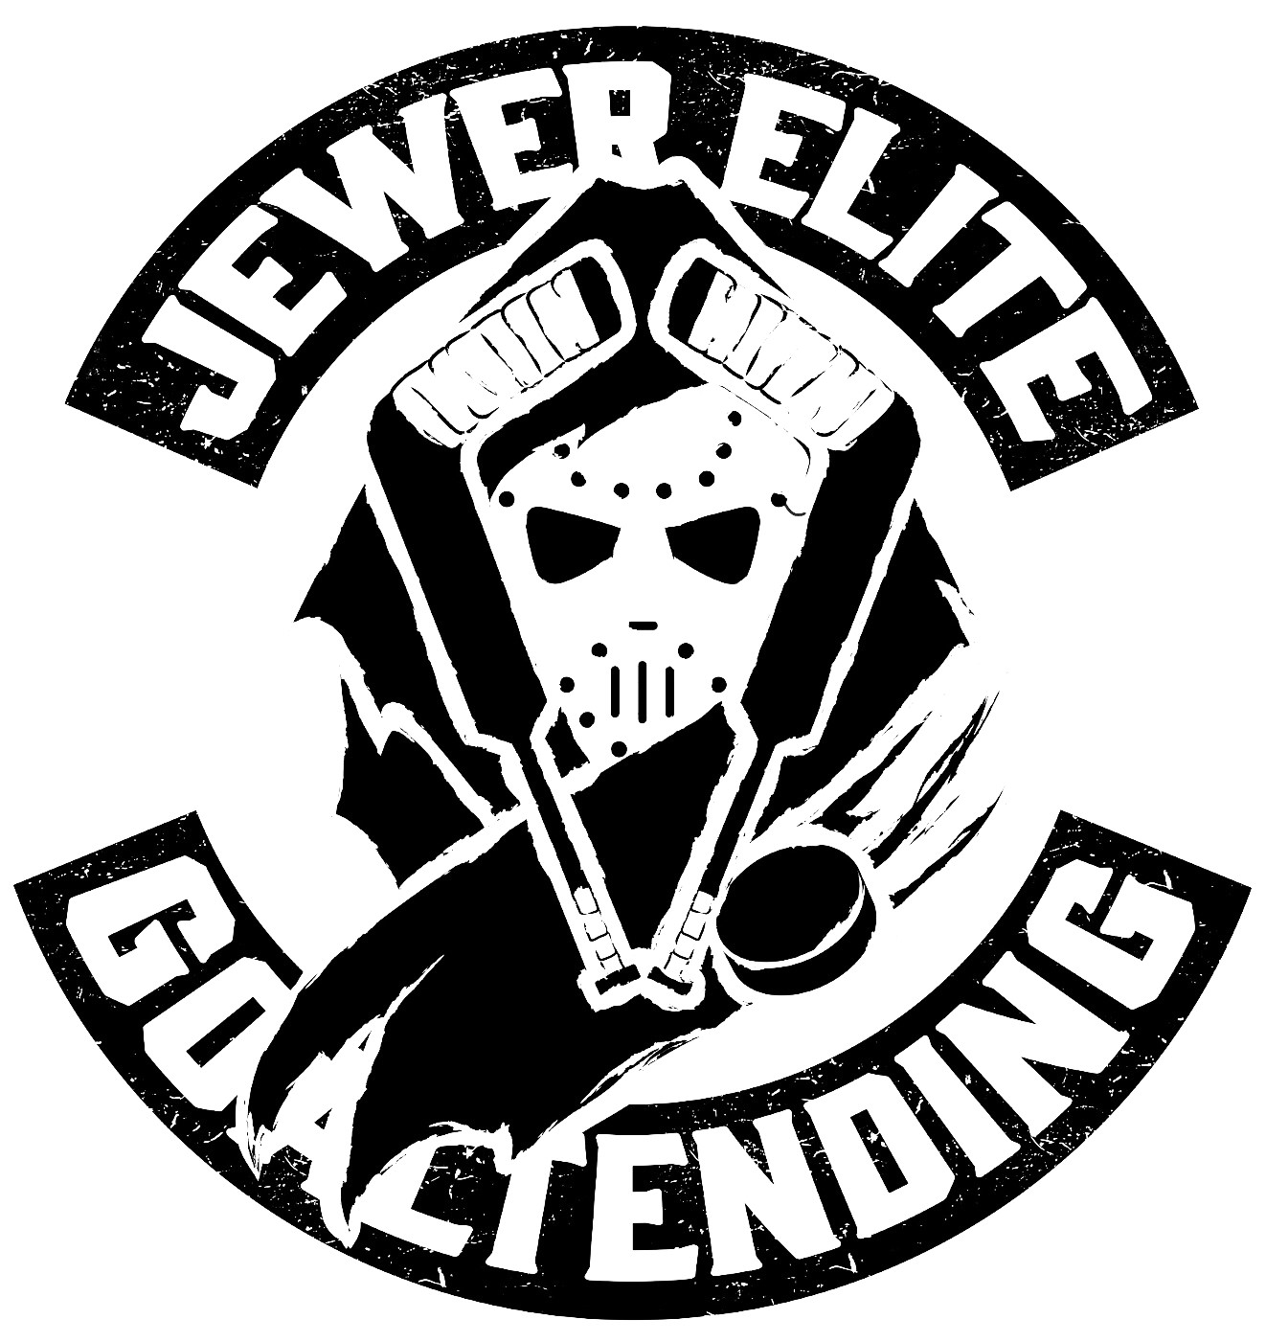

FACTS ABOUT JEG
JEG is owned and operated by Newfoundlander and former Newfoundland Goaltender Doug Jewer. Doug played in the highly competitive Hockey East conference of NCAA Division 1 competition with Northeastern University. He also MVP, Top Goaltender, And two time AllStar Game MVP of the CCHL during his junior career. While being courted by several NHL teams in college Jewer got injured and these injuries continued to plague his playing career. He also competed for the Carleton Ravens in Canadian University sport CIS. He was also the winner of two Herder Championships as a member of the Grand Falls Cataracts in local Senior hockey competition and was the playoffs MVP. During his career, Doug has had the opportunity to work with some of the worlds best coaches and some of the worlds best goalies, such as Dominic Hasek and Marc Andre Fleury.
At JEG lead instructor Doug Jewer is hands on and involved in every activity that we do. Our semi private sessions for younger goalies now have additional coaches on, even further improving our goalie coach ratio. Every goalie gets their own net for the entire session in our on ice format and all goalies are video taped and uploaded for further review.

SESSION FORMATS
Outlined below is a list of our various on-ice sessions and programs available. All sessions are recorded from several different camera angles and are available for further critique via specialized programming. You can read more about video critiques below.

SEMI PRIVATE SESSIONS
The majority of our sessions are in a semi private format. This is the structure that has become unique to JEG and has allowed our goaltenders to develop and grow rapidly. Each session has an absolute maximum of 6 goalies to ensure that every goaltender gets their own net for the entire session, ample time to work on each skill and technique developed or worked on in the session, and adequate instruction time from the lead instructor. Shooters in all sessions are a control variable, meaning they are there for the BENEFIT OF THE GOALIES, NOT THEIR OWN. Each drill is catered to or adjusted to match each goalie’s skill level and development needs. All sessions are video taped and uploaded to the Jewer Elite YouTube channel, or can be critiqued and shared using the CoachCast software if goalies wish to participate in this part of the program.
PRIVATE SESSIONS
Private sessions are also available in either a 1 on 1 or 1 on 2 format. Drills completed in the private session are similar to those in the semi private sessions however the lead instructor’s entire focus is on the goalie or goalies participating for the entire session.

EDGE & CONDITIONING SESSIONS
The Edge and Conditioning Session is JEG’s own take on a goalie power skating session. Operating in pairs and running on a timed circuit, these sessions stress edge work, conditioning, skating, movement, and technical drills in a 30 second on, 30 seconds off format, stressing speed, agility, and endurance.

GROUP SESSIONS
We also do large group sessions however normally this is done through contract with minor hockey groups. We are looking to introduce this format in the near future.

PROGRAMS AND PRICING
Our programs are flexible, offer make up sessions, and have the option for payment plans as well for those who request them. We also make specific programs and schedules dependent on the schedule your goalie already has in place, however availability for this type of service is usually dependent on how quick you wish to schedule such a program to ensure the spaces you require are available. Our programs are all designed with maximum goaltender development and benefit in mind.

PROGRAMS
Each program uses controlled shooters, limited session numbers, extensive video recording and uploading for goaltender/parent/Coach review, and every session is ran by lead instructor, Doug Jewer.. Some programs use specialized software to distribute and critique videos, if you would like more information on this program (video distribution and critiquing) please contact us for further information.

12 MONTH PROGRAM
- 45 Sessions in Total
- 34 Semi Private Throughout Fall (12) Winter (12) and Summer (10)
- 10 Edge and Conditioning Sessions in Summer or Fall
- 1 Private Session
- 2 Pieces of JEG Apparel
- CoachCast membership
Total: $3,800.00 Plus HST
12 Month members receive other programs like JEG YOGA AND DRY-LAND tax free and with additional discount.

HOCKEY SEASON PROGRAM (September-April) (Formerly Yearly)
- 24 Semi Private Sessions Throughout Fall (12) Winter (12)
- 1 Private Session
- JEG Jersey
Total: $2,300.00 Plus HST

SUMMER ELITE(YOUTH ELITE) PROGRAM (YOGA INCLUDED)
- 10 Semi Private Sessions (1 Per Week)
- 10 Edge and Conditioning Sessions (1 Per Week)
- 10 Goalie Yoga Sessions
- JEG Jersey
Total: 1875.00 Plus HST
At Jewer Elite Goaltending we have both an Elite and Youth Elite program, both are priced and structured the same from a standpoint of ice time and activity involvement, however the intensity and difficulty of sessions is varied depending on the age and skill level of the goalies involved. The format remains the same, creating an elite training platform for goaltenders of all ages. This program, like all other JEG programs, is a program based on achieving results. Last year at the Elite level, the program was able to help several local goaltenders prepare successfully for moving abroad with their hockey careers and furthering their opportunities in the game, while at the youth level, was able to take a goaltender from his first time wearing pads to competing for Atom All-Star in his first year of Atom eligibility and making a team in a very competitive organization. While results vary for each goalie, the program can without doubt deliver results and elevate your goalies game

SUMMER ELITE ICE ONLY PROGRAM (NO YOGA)

- 10 Semi Private Sessions (1 Per Week)
- 10 Edge & Conditioning Sessions (1 Per Week)
- JEG Jersey

For those in the 12 Month program you would be included in this portion of the on-summer program.
Total: $1,475..00 Plus HST

SUMMER 10 SESSION SEMI PRIVATE PROGRAM
- 10 Semi Private Summer Sessions
- JEG Jersey
This program includes a weekly semi private session and is great for those who want to steadily maintain their technical development throughout the summer. Availability of this program is somewhat dependent on what spots are remaining following the enrollment of our elite summer programs and and 12 Month programs so if you wish to obtain spacing in this form of the program it is best to register as soon as possible.
Total: $975.00 Plus HST

10 SESSION SUMMER PRIVATE PROGRAM
- 10 Private Sessions with Lead Instructor Doug Jewer

This program is for goalies who wish to have the complete attention and focus of lead instructor Doug Jewer for the entire session. A one on one session is by far the most beneficial hour of training available from a technical development standpoint as every minute detail of your session is reviewed and analyzed.
Total: Please Contact for Pricing and Availability

SUMMER WEEK LONG CAMP 2018
This summer we will be incorporating a week long camp for those who are interested. We are still in the process of finalizing dates and details for this camp however we will use JEG’s reduced number format to create a very unique week long camp. Please follow up for details.

SUMMER WEEKEND CRASH CAMPS
This summer we will also be having smaller weekend crash camps to allow for those interested to sign up for a weekend tune up. Like our week camp we are finalizing the structure and schedule for this so please follow up for more details.

FALL AND WINTER ON-ICE PROGRAMS
Changing for this year, both our Fall and Winter Programs will have 12 sessions for both the Fall and Winter portions, a slight change from the 14 and 12 sessions offered this past year or that are featured in the Season Program listed above.
FALL PROGRAM (September-December)
- 12 Semi Private Sessions
- JEG Jersey
Total: $1,150.00 Plus HST

WINTER PROGRAM (January-April)
- 12 Semi Private Sessions
- JEG Jersey
Total: $1,150.00 Plus HST

PERSONALIZED PROGRAM
At JEG we also do personalized programs meaning, we will cater the program to you needs and your schedule (depending on ice time availability). What we do with this program is the goaltender submits their requested number of sessions in the requested formats available (semi private, edge and conditioning, private) and we will cater the program to their schedule and demands. Cost is determined by the number of sessions and type of sessions requested. Please contact if interested. The personalized program can be completed at any time of year.

WALK ON SESSION
Walk on to one of our semi private sessions anytime of the year. Space and availability varies so please contact to book available space!
Total: $80.00 Plus HST
With Video Edit and Upload (Critique Separate) 92.50 Plus HST

OFF-ICE TRAINING AND ACTIVITIES
DRY-LAND TRAINING
All of our dry-land programs are specific to the goaltending position and in 2018, will be specific to the needs of each goaltender involved. The program works on muscular development, muscular endurance, cardiovascular endurance, plyometrics, speed and agility, explosion, flexibility, hand eye, focus, and other facets of a goaltender’s game.
Each program is catered specifically to each goalie and is altered depending on the age group. For example, our youngest Introductory dry-land group focuses more on footwork, hand eye, and endurance with little to no weight training, perhaps only an introduction to proper technique.
We use a combination of proper technique, innovative training techniques, modern and classic methods, and the best in modern technology, such as fit lights, swivel vision, etc, to provide the best, most engaging dryland program around.

Location: we will be using a variety of indoor and outdoor facilities to maximize the development and outcome of our dryland program. We will be offering our dryland inside the city and depending on demand we may also do a program in Bay Roberts similar to last year.

ELITE PRO PREPARATION GROUP
Perhaps the most influential and beneficial goaltending dry-land program available. This program is for those goalies looking to bring their game to the next level. The intentions of this program are to you like a PRO. Designed in consultation with physiotherapists and the input of Orthopedic surgeons, this program is meant to emphasize all the areas listed in our dry-land training explanation above. This program is highly demanding and available usually on an invite basis.
Completed in a semi private format.
4 - 2 hr sessions per week for 10 weeks
40 Total Sessions
Total: $1,400.00 Plus HST

INTERMEDIATE DRY-LAND GROUP
Completed in a semi private format.
A great way to prepare your Bantam or Pewee Age Goalie for the coming season While focusing on the goalie specific development areas listed above, . this program is designed to give these goalies a proper introduction into weight training and teach them the proper techniques required to weight train properly. The program advances past the introductory level and into light weight training.
3 – 1.5 hr sessions per week for 10 weeks
30 Total Dry-land Sessions
Total: 1,000.00 Plus HST

BEGINNER DRY-LAND PROGRAM
Our beginner dry-land program is great for any young goalie looking to stay in shape an stay sharp through the offseason. Combining game and competition with beneficial training techniques creates a fun and stimulating atmosphere for your young goalie while he advances his skill set.
2 – 1 hr sessions for 8 weeks
16 Total Dry-Land Sessions
Total: 450.00 Plus HST

PROGRAM ADDITIONS
COACH CAST CRITIQUE PROGRAM
This is a mobile application that allows peer to peer video sharing between the Coach and the goalie or parent. The video can then be critiqued using the program to further increase the developmental session value for each goaltender. Video review is at the peak of most professional and amateur sport development these days, and this software puts us at the forefront of technological game.

MARKETING AND REPRESENTATION PROGRAM
This is a program catered to some of our older elite goalies whom are looking for the opportunity to expand their hockey horizons and move on to other levels. Please inquire for more details.
COMING SOON..
UNLOCK GOALTENDING ONLINE SEMINARS
In the next few weeks you will have the ability to sign in to JEG’s online classroom and partake in our online classroom seminars! This is a unique learning program which allows us to reach out to goalies all over the planet! Cost and details to follow but we hope this is a new and unique opportunity we can all take part in to further your goaltender’s learning and development. Each seminar with have various topics and video accompaniment. Those in the 12 Month program will receive seminars at a discounted rate.

REGISTRATION INFORMATION & PAYMENT

If you are interested in registering for one of our programs we will forward out the requested form. There are payment plans available, however they must be approved and signed by both parties. Methods of Payment:
- Email Money Transfer
- Cash
- Check
- Available March 20th, Online Credit Card Payment

We require a down payment to reserve space in any program. Remaining balance is due prior to the start of the program, unless otherwise outlined in an approved payment plan.

Policies
- All goaltenders and shooters must have appropriate CSA approved Ice Hockey Equipment to participate in any session or program. If minor hockey age, the participant must be registered for minor hockey.
- Payment Plans are offered for various programs. There is a down payment required to reserve space in any program. This down payment comes off the total remaining. Any payment program needs to be approved and signed. Failure to comply with the agreed payment plan will result in your goalie not being allowed to participate in sessions.
- Make-Up Sessions. If you have a conflict and notify us in appropriate time we will gladly provide a make up session for you. However, once the make up session is scheduled, if there is a conflict with this time we can not make up the session again. There is one opportunity for the make up session and that is it. With limited numbers, when we schedule a make up we are taking a possible make up slot, or a walk on spot, away from another goaltender. Therefore, once the make-up is rescheduled if missed, we cannot provide a make-up session for the missed make up session. Make up sessions do not carry over from program to program. Once the stated completion date to a program is completed we are not obligated to provide make up sessions following the normally stated completion of the program. However, if you are signed up for consecutive programs we will look at carrying over make up sessions from one program to the next but there is no guarantee we will carry over sessions.

